**COMPUTER GRAPHICS MINI PROJECT – SIMULATE CELLULAR AUTOMATA THROUGH CONWAYS GAME OF LIFE**

The bold text are project file names. The c files within each contains the relevant code.

You can download the entire project folder and run on Code Blocks, or copy the main.cpp file within each folder to a new Code Block OpenGL project.

List of files in repository:

1. plant – drawing of 1 plant
2. plant3d – drawing 3 plants with lighting effects
3. game-of_life -basic algorithm implementation, press ‘n’ to see next iteration
4. game-of_life2 – added animation, color
5. game-of_life3 – added color based on age groups
6. game-of_life4 – added 5 color scheme, inc old age, fixed pause

**Plant** file contains code to draw 1 plant

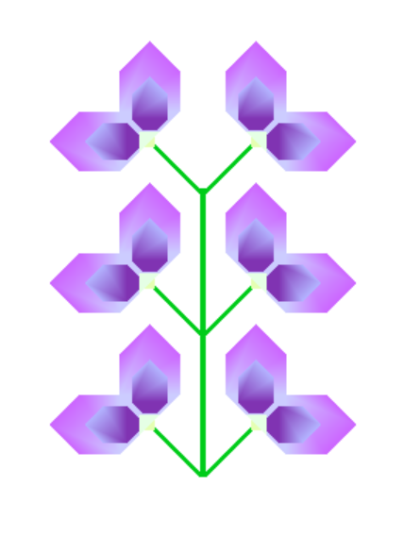

**Plant3d** is an attempt to draw a garden scene

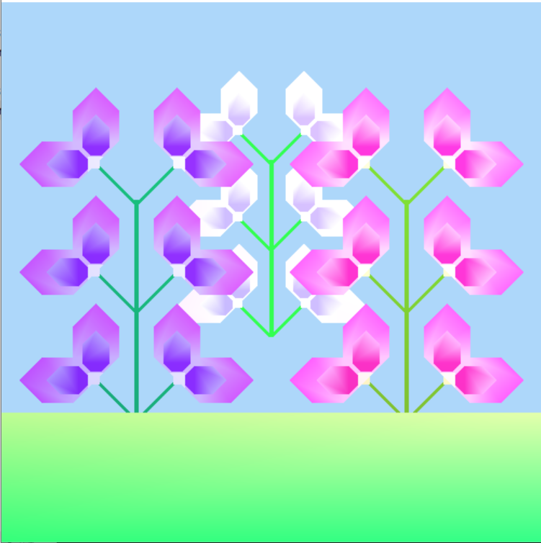

Problem in getting the grass to reach the plant in z axis

GOAL:

Green = feature added

**game-of_life** file contains the basic idea of the algorithm to be implemented. It goes to the next step when ‘n’ is pressed

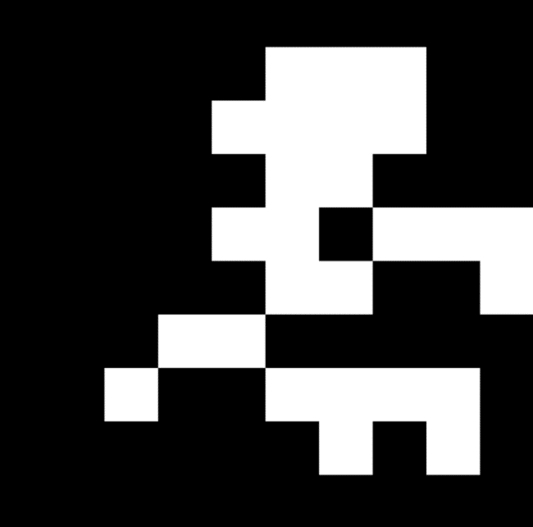One iteration Another iteration

This algorithm was written by me, with some reference from:

* https://kylewbanks.com/blog/tutorial-opengl-with-golang-part-1-hello-opengl

Limitations:

* User has to press ‘n’ everytime to see iteration
* Start state has to be manually coded

**game-of_life2** implements colour, user interactivity

Refered for use of timer and interactivity: <https://www.youtube.com/watch?v=NPvwGh2ucPk> (codelink: https://www.youtube.com/redirect?q=https%3A%2F%2Fdrive.google.com%2Fopen%3Fid%3D0B8GbMg0HqpuZS0FTZzJqN2pKSmM&v=NPvwGh2ucPk&event=video_description&redir_token=bcgRKe7gEAb2nZQjFYyhDN7-nQh8MTU5MDMxODUzOEAxNTkwMjMyMTM4)

* User can add organisms by pressing 2 (pause), using mouse
* Press 1 to view animation
* Press 3 to reset to blank state
* Gives colour to organism based on age (darker=’young’,lighter=’old’) – sometimes difficult to see
* Adds concept of old age
* Problem: When user pauses, all organisms die from old age.

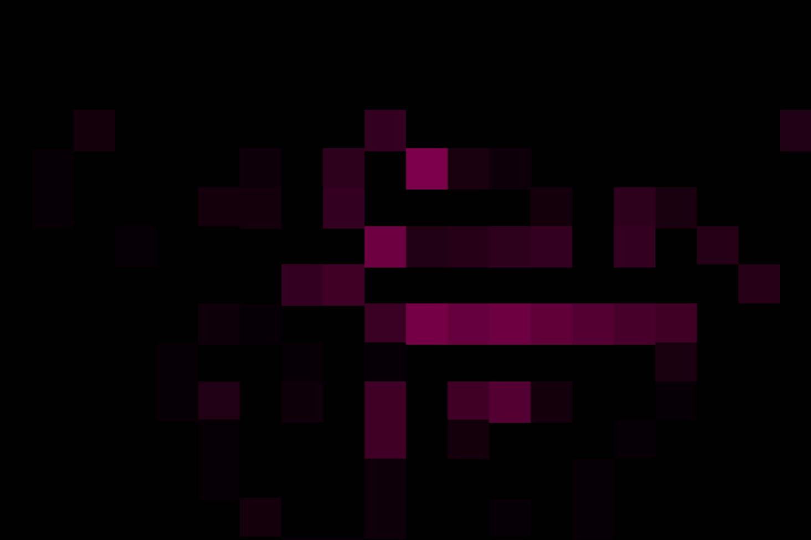Smaller window size



Larger window size

**game-of_life3** similar to previous one, but adds colour based on age groups, example 1 color for 0-5, another for 5-10, so on till age 30

* More clearer to view different age groups
* Lower age groups are lighter color, and become darker as they get older
* Can observe formation of colonies
* Fixed the pause problem

*Colour scheme 1*

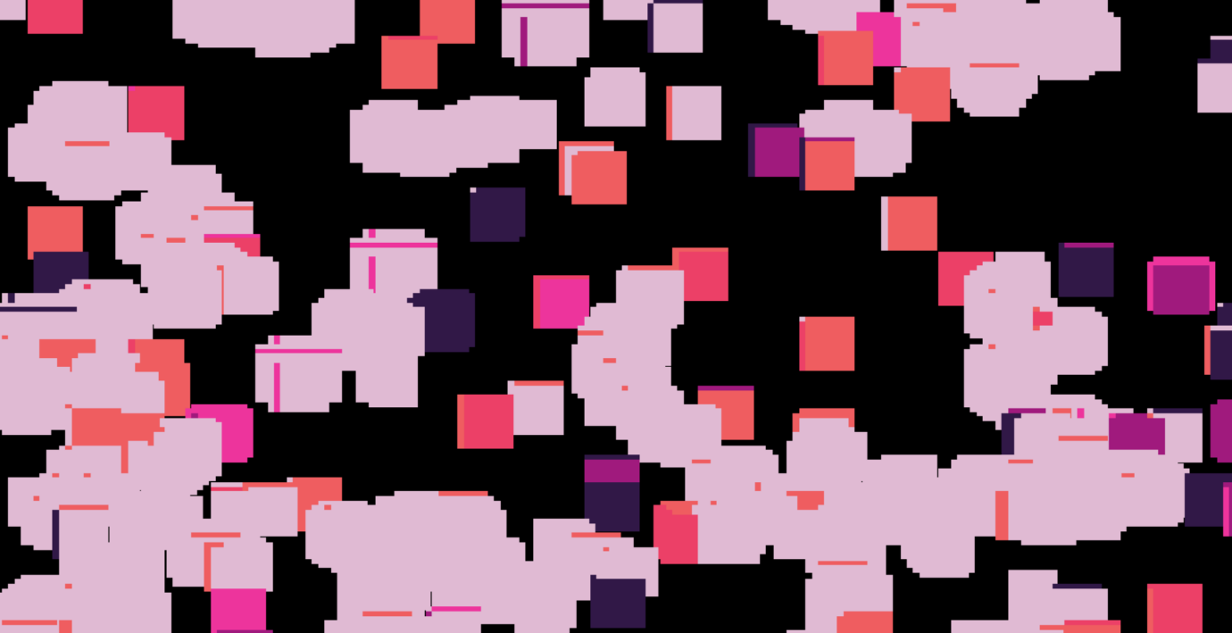

Colony formations based on age group is very clear

*Colour scheme 2*

Initial state:

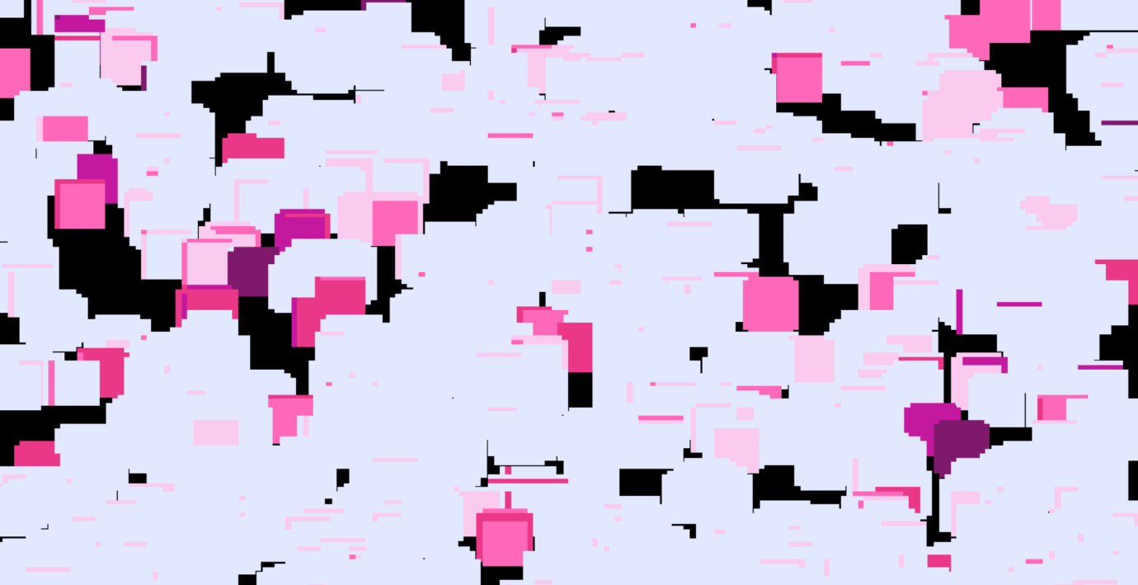

Intermediate state:

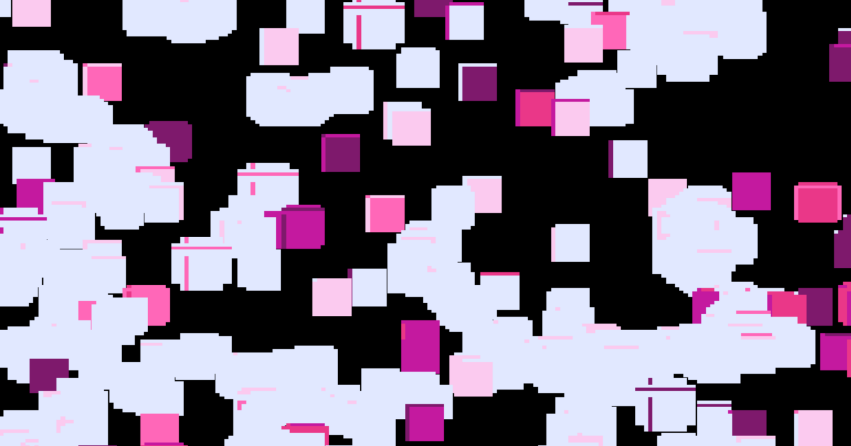

Final state:

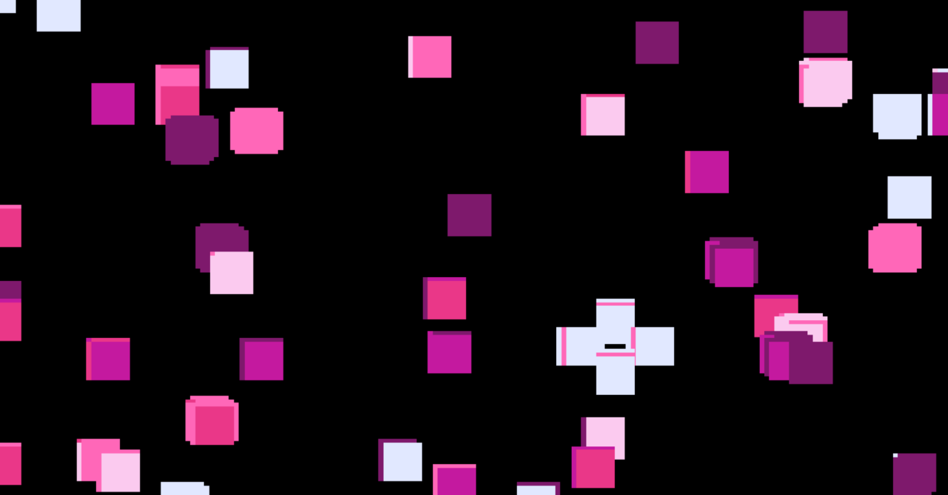

Color scheme:



**game-of_life_4** : final version, with old age as 50, with additional color, reduced point size

* Old age at 50, additional color
* Point size reduced

Color scheme used:



Link for color scheme: <https://coolors.co/e1e8ff-fbcaef-ff67b8-ea3788-c4199f-7e196c-ffc759>

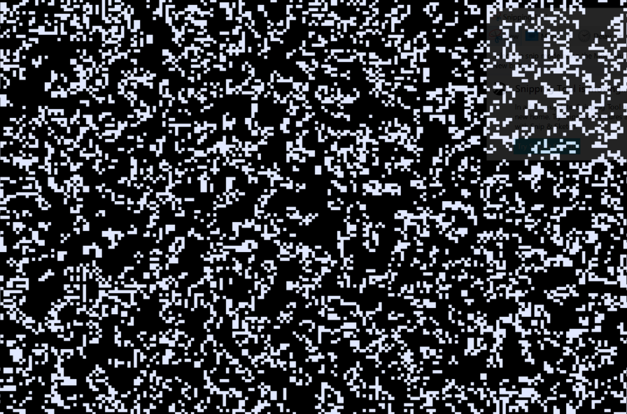

Initial state

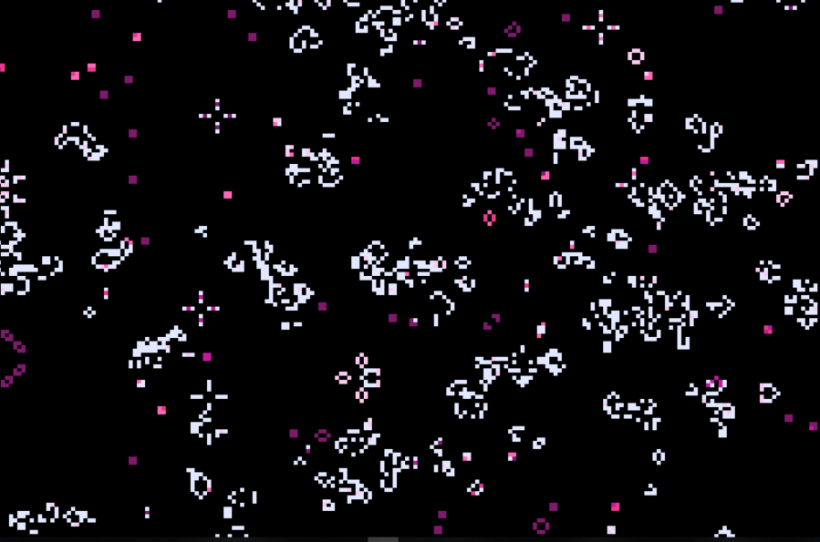

Intermediate state

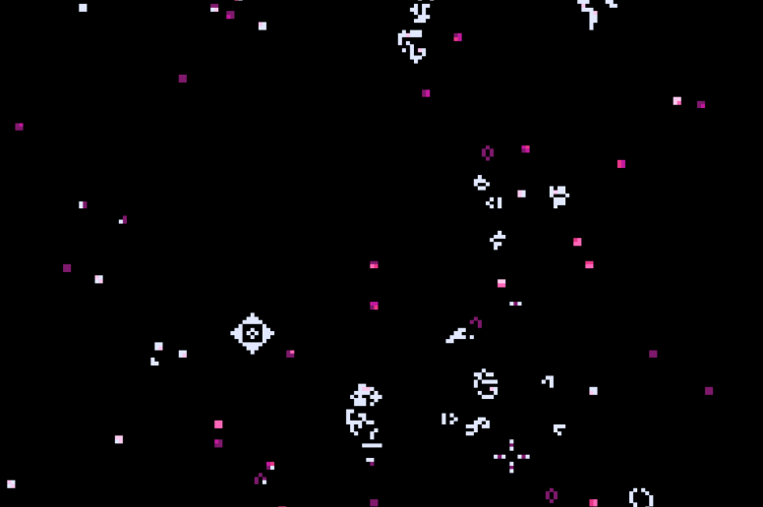Near end state

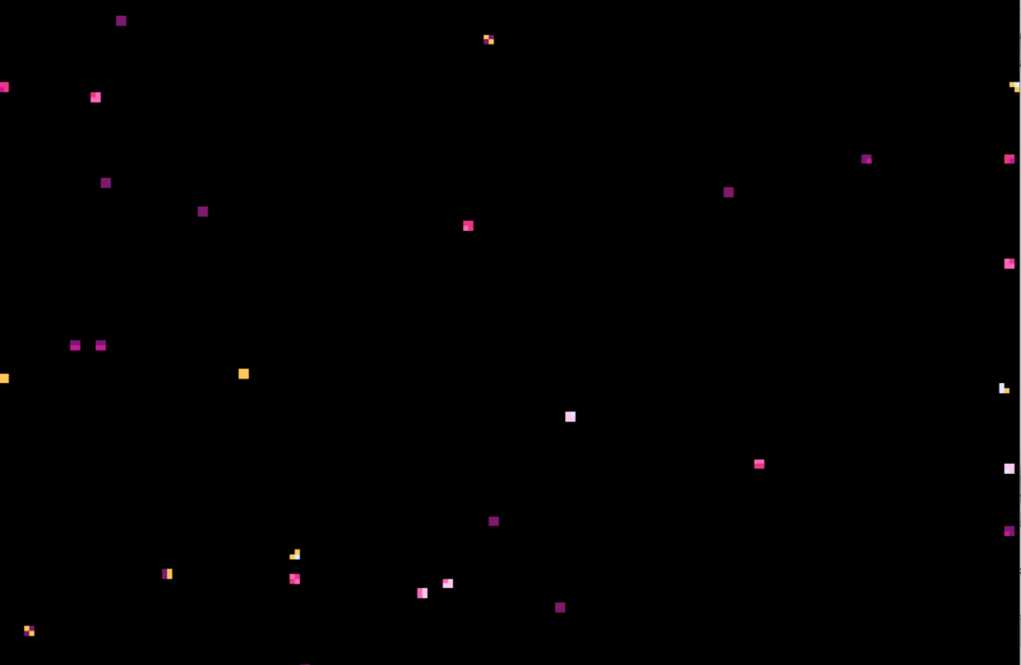

End, society is sustainable, equal births and deaths.

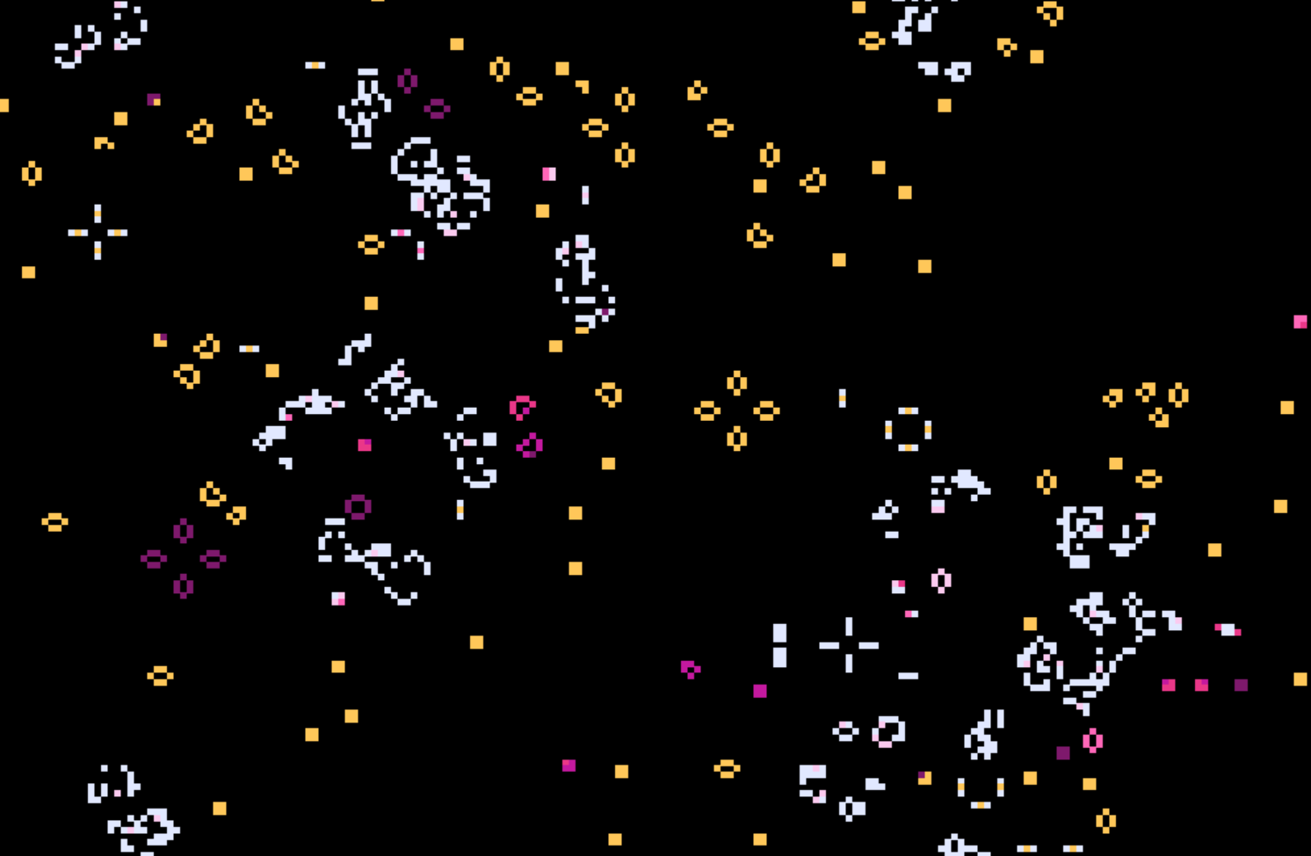

With old age as 300

Next step could be to change organism from point to plant, but I think it will become too complicated, what do you feel?

PROGRAM: Please see the code for final version in folder **game-of_life_4, file main.cpp**

Comments are written, please feel free to ask any doubts/clarifications

PARAMETERS THAT CAN BE MODIFIED:

Age for old age(automatic death) : **old_age**

Animation speed (milli sec): **speed**

Size of point : **point_size**

**Summary of features in final version:**

* User can pause game by pressing 2
* User can resume game by pressing 1
* User can reset board to empty by pressing 3
* User can add organisms(points) with leftmouse click/drag in **pause mode**
* Color of organism changes with age
* Once old age is reached organism dies

**Is this sufficient for mini project?**